Brainrot Brigade Adventure Module: Lost in the Stars

Adventure Overview
Lost in the Stars is a narrative-driven puzzle adventure designed specifically for Brainrot Brigade. Players become junior crew members aboard the spaceship Celestis, thrown into crisis after a devastating asteroid collision. This module emphasizes logic puzzles, collaboration, and creative problem-solving. Each encounter presents a distinct puzzle scenario grounded in the game’s mechanics, with clear guidance for the Game Master (GM) to facilitate smooth gameplay.

Timer Mechanic (GM Guidance)
To add urgency and increase the challenge, this module uses a real-time timer in the session. This works well for keeping the game within a class or club session and adds narrative tension without requiring complex tracking.
Assign a total mission time (we recommend. 60 minutes to restore the Celestis and escape) and let players know their crew is racing against failing life support or an approaching hazard. You should announce time remaining after each encounter or, even better, run a visible countdown. To heighten the drama, reduce the available time for a harder challenge. If the encounter calls for players to be ‘locked out’ for any period of time, they may communicate to one another, but they cannot touch any implements or props during that time.
A lower time limit encourages fast collaboration, sharper decision-making, and reliance on teamwork and Laser Focus for clues, making every roll feel more consequential. Be generous with hints if time is tight - this mechanic is meant to boost energy, not cause frustration.

GM Introductory Notes
- Audience: Suitable for players aged 9–13 or beginners to RPGs.
- Playtime: Approximately 60–90 minutes.
- Materials Needed: Printed puzzle handouts, pencils, scratch paper, dice. Timer.
- Tips:
  - Clearly explain each puzzle scenario.
  - Encourage players to discuss and collaboratively approach puzzles.
  - Use the “Laser Focus” mechanic liberally to give clues or insights when players are stuck.
  - Allow creative solutions through character-specific gear and roleplay.
  - Encourage players to leverage their role specialties and character skills to assist puzzle-solving.
  - Set the timer to somewhere between 60 and 90 minutes - less time = harder challenge

Adventure Setup (Read Aloud)
You are junior explorers aboard the renowned starship Celestis, a ship known for charting distant galaxies and uncovering hidden worlds. Your mission seemed routine, a simple exploration into unknown space—until disaster struck.
An asteroid storm suddenly bombarded your vessel, knocking out critical ship systems and leaving you adrift in uncharted space. To make matters worse, Captain Arden has vanished! Now, as junior crew members, the responsibility falls on your shoulders. You must rely on your courage, teamwork, and quick wits to restore the ship's functions, find Captain Arden, and safely navigate home.
Your journey begins amid flashing emergency lights, sparking control panels, and the eerie silence of deep space. Time is against you—every decision counts. Time is ticking, you have until the timer runs out to make your way back to the Star Explorers Guild. Good luck, crew!

Encounter 1: Power Restoration (GM Reference)

Encounter Setup (Give players Handout 1 and Read Aloud)
The ship’s emergency systems are down. You’re junior crew aboard the Celestis, and the captain has left you one critical task:
Activate the Viewscreen and the Signal Uplink to receive the captain’s secret message.
Only five switches are still working (A–E), and each one toggles power to a mix of systems. That means that pressing a switch will turn ON any connected system that’s off—or turn OFF any that are already on. All systems are off right now.
Your goal:
Turn ON only the Viewscreen and Signal Uplink. All other systems must remain off to save power.

Cost of Failure
To raise the stakes and incentivise thoughtful problem-solving, failed switch combinations have escalating consequences. After each incorrect attempt:
- First Incorrect Attempt: Warning klaxon sounds. Players feel the urgency rising.
- Second Incorrect Attempt: Minor system instability. Lights flicker. Crew must stabilise power with a Logic roll, describing how they are helping. Failure means a -1d6 penalty to their next skill roll due to distraction.
- Third Incorrect Attempt or More: System overload risk. Failing this causes the players to reroute through a slower backup path (adding narrative time pressure). The bridge console locks for 1 minute unless overridden with two successful skill checks. Have the players describe how they use their skills to override the system lock.
Encourage players to use their:
- Roles: Engineers can reroute power; Hackers can simulate combinations offline; Diplomats might calm the crew or request system overrides.
- Gear: Scan tools, bypass kits, or diagnostic tablets may count as being prepared.
- Laser Focus: Rolling exactly their Core Number may reveal the length of the correct combination or which switch not to press first.
Let smart tactics reduce these penalties. For example, a player who predicts an error and sets up a bypass beforehand may negate consequences with a good roll.

Solution (GM only)
Laser Focus Hint 1: It will take four presses to complete the sequence
Laser Focus Hint 2: Don’t start with switch ‘C’, though it seems like the best one
Switches A, B, D, E activate the Viewscreen and Signal Uplink correctly.
Once successful, the Viewscreen sparks to life, illuminating the captain’s scrambled message, setting up the next puzzle encounter.

Encounter 2: Decode the Captain's Message (GM Reference)

Scene Setup (Give Handout 2 and Read Aloud)
The screen blinks uncertainly, then crackles with distorted audio and flickering letters. A garbled message begins to scroll across the screen - clearly encrypted. Somewhere in this nonsense is a vital instruction from Captain Arden. You'll need to decode it.
Captain Arden’s voice - faint and glitchy - says one word clearly before cutting out: “...Cipher…”

GM Guidance
- Puzzle Logic: A Caesar cipher where each letter in the message has been shifted backwards in the alphabet by 12 positions. Players must determine the shift and decode the message.
- Player Actions:
  - Players can roll Logic to deduce the correct shift.
  - Instinct rolls can be used to intuit patterns based on phrasing or frequent letters.
  - Roles like Hacker or Scientist may grant bonus dice for being experts in cryptographic analysis or linguistic reasoning.
  - Encourage creative gear use (e.g., cipher wheels, translation software, linguistic AI implants).

Cost of Failure
Incorrect cipher keys may scramble the message further:
- First Incorrect Attempt: Message becomes harder to read (letters blink erratically). Players suffer a -1d6 to the next decode attempt unless stabilised with a relevant skill check. Get them to describe how their Role helps them.
- Second Incorrect Attempt: The screen begins to overload. Players must succeed on a skill based cooldown roll (1 success) to avoid a system reboot which would delay progress by 60 seconds. They should describe how their Logic or Instinct helps the situation.
- Third Incorrect Attempt or More: The message is lost unless a successful Emergency Data Recovery is made (2 skill successes or 1 Laser Focus insight). If this fails, fallback logs must be located elsewhere in the ship, shortening the available mission time by 90 seconds.
Let players overcome or avoid consequences using their Roles:
- Hackers might isolate the file for sandbox decoding.
- Engineers could cool the console physically.
- Diplomats could roleplay calming a nervous NPC assistant who suggests the right shift.

Solution (GM only)
Shift = 12. Decoded Message: "THE LIFE SUPPORT SYSTEM IS BAD. RESTART IMMEDIATELY!"
This message sets up the next encounter - restarting the systems in the correct order.

Encounter 3: System Reboot (GM Reference)

Scene Setup (Read Aloud)
The message from Captain Arden is clear - life support is critical. But rebooting ship systems isn't simple. Each subsystem has to be restarted in precisely the right order to prevent catastrophic failure. One wrong move, and you could fry a core or cascade a power fault through the whole grid.
The crew stands before the reboot console, a glowing list of ship systems displayed on the monitor. Each has a code next to it. A diagram of dependencies pulses on the screen, and the reboot interface awaits your command.

GM Guidance
- Puzzle Logic: Players must sequence 8 systems in the correct reboot order, based on conditional constraints (e.g., “X must come before Y”).
- Player Actions:
  - Logic rolls help interpret or test dependencies.
  - Instinct rolls might reveal hidden relationships or let players spot inconsistencies.
  - Roles like Engineer, Scientist, or Analyst have strong justification for being experts—grant bonus dice.
  - Equipment like diagnostic tablets or systems manuals may offer players the "Prepared" bonus.

Cost of Failure
Getting the sequence wrong introduces mechanical strain and complications:
- First Mistake: Reboot sequence halts. Players must stabilise power with a successful Logic or Instinct roll (1 success). Have them describe how their Logic or Instinct helps them. Otherwise, lose access to any equipment for the next skill check - they must go unprepared (-1d6 next skill check)..
- Second Mistake: Feedback surge. Sparks fly. One character suffers a minor setback (e.g., smoke inhalation = -1d6 until rested or aided).
- Third Mistake or More: Core system locks down. To proceed, players must reroute control from a secondary terminal in another part of the ship. They cannot attempt the puzzle again until they all succeed on a Logic or Instinct roll, OR one of them gets Laser Focus.
Creative player thinking can reduce or negate these costs:
- A Hacker might simulate the reboot sequence in a virtual environment before executing it.
- An Explorer might physically inspect system connections and identify safe sequences.
- A Diplomat could consult logs or mediate with the ship’s AI for a hint.
Encourage collaborative planning and let the group tackle it as a logic puzzle aloud.

Solution (GM only)
Correct order:
- Life Support (3)
- Sensors (7)
- Artificial Gravity (2)
- Communications (4)
- Defence Systems (8)
- Navigation (5)
- Engines (1)
- Shields (6)
Rebooting these in the correct sequence leads directly to the next phase: reactivating the ship's navigation computer.

Encounter 4: Program the Navigation Robot (GM Reference)

Scene Setup (Read Aloud)
With the systems humming back to life, your focus shifts to the ship’s navigation module. Alarms still blink—damage has corrupted the auto-navigation program. To steer safely, you’ll need to manually reprogram the Celestis’ helper robot. A small diagnostic robot sits ready in the centre of the bridge, its photoreceptors flickering expectantly. Captain Arden left one last cryptic note: “Use the reboot code to initialise the robot’s movement program.”
A gridded map appears on the screen. The robot must be guided to scan the sector from its starting position at the centre.

GM Guidance
- Puzzle Logic: Each number in the 8-digit reboot code (from the previous puzzle) corresponds to a directional move. Players interpret the code and track movement on a 5x5 grid.
- Player Actions:
  - Logic rolls can be used to formally decode and execute the path.
  - Instinct rolls may allow players to intuit correct movements or spot pattern mistakes.
  - Roles like Pilot, Explorer, or Hacker may apply.
  - Gear such as a nav scanner, plotting tablet, or motion beacon may count as preparation.

Cost of Failure
Missteps in the robot's movement have escalating consequences:
- First Error: The robot hits a wall and must be reset, costing precious time. Players must make a Logic or Instinct roll (1 success) to realign its position before they can try again. Have them describe how their Logic or Instinct helps them.
- Second Error: The robot drifts into a restricted zone, causing an automated proximity alarm. The bridge is bathed in red light until a succesful Logic or Instinct roll resets the alert. Have them explain how their Style helps them out here.
- Third Error or More: Navigation system destabilises. The grid begins to shift unpredictably. From now on, all coordinate tracking attempts take -1d6 unless stabilised by a ‘technical’ character in the group making a successful Logic roll.
Creative approaches can help:
- A Diplomat might ask the robot questions, interpreting beeps and chirps to gain directional clues.
- An Engineer could install a temporary guidance override.
- A Hacker might interface directly with the movement core to preview or simulate moves.
Encourage the team to sketch the grid or physically map the robot’s journey.

Solution (GM only)
Using the reboot sequence 3,7,2,4,8,5,1,6:
- 3 = left
- 7 = diagonally up-right
- 2 = down
- 4 = right
- 8 = diagonally down-left
- 5 = repeat last direction (down-left)
- 1 = up
- 6 = spin (no movement)
Final position: (2,4)
With the robot now locked in, its scanners begin mapping the system. You’re ready to chart a course through the stars.

🛰️ Encounter 5: Navigate the Star Map (GM Reference)

Scene Setup (Read Aloud)
The navigation robot hums softly as it completes its scans. A holographic star map bursts into life on the viewscreen, showing a complex web of constellations, nebulae, and celestial hazards. The safe route home lies buried somewhere within the coordinates—but it’s not marked. Only a trail of riddles, poetic clues, and symbolic markers remain.
You’ll need to work together, interpret the signs, and plot the final course toward safety... and the headquarters of the Star Explorers Guild.
The first clue is tied to your robot’s last known position.

GM Guidance
- Puzzle Logic: Players start from a known position on a grid (2,4 from the robot’s path in Encounter 4) and must follow a series of riddle-like instructions to determine the next steps and destination.
- Structure: This is a multi-stage movement puzzle with embedded spatial reasoning and visual metaphor.
Let players collaborate freely. The clues reward both direct thinking and lateral interpretation.
- Player Actions:
  - Logic rolls can help break down and test spatial instructions step-by-step.
  - Instinct rolls can be used to intuit poetic meanings or metaphors in the clues.
  - Roles like Explorer, Pilot, Diplomat, or Scientist are great fits.
  - Gear such as astro-maps, symbol dictionaries, starfield overlays, or linguist tools may count as preparation.
Let them sketch the map or track the journey on paper or whiteboard. Encourage them to voice interpretations of the poetic lines and follow the chain of reasoning as a group.

Cost of Failure
Each wrong interpretation of a clue increases the risk of the ship veering off-course or triggering a navigation hazard:
- First Misstep: The ship veers into a dust cloud. Internal sensors must recalibrate (1 Logic or Instinct success), or all future movement checks are treated as unprepared (no bonus d6 from gear) for the next skill check.
- Second Misstep: A radiation pocket disables the viewscreen. One player must reroute visuals to an auxiliary screen using Instinct or Logic and describing how they do it. Otherwise, players lose sight of the star map (GM describes/answers vaguely for 1 minute).
- Third Misstep or More: The ship enters a gravity anomaly. Time becomes erratic - take 2 minutes off the game timer unless stabilised by a full Logic or Instinct success.
Letting players roleplay small scene cutaways - e.g. Engineering rerouting power, a Hacker creating a real-time translation layer for poetic riddles - this will create variety in the flow of the puzzle.

Solution (GM Only)
Starting from (2,4) on a 5×5 grid:
- Clue 1: “From your starting position, move 3 spaces to the right (east), then 2 spaces down (south).”
→ (2,4) → (5,4) → (5,2)
- Clue 2: “I'm ringed with grace, floating in space,
Seven down, and one left is the place.”
→ From some point (likely the centre), subtract 7 from y and 1 from x → (4,5) → (3,-2)
(BUT players must deduce that this is metaphorical—interpret as reference to Saturn-like symbol at (4,2))
→ Final answer: (4,2)
- Clue 3: “From your current position, move left and down until you land directly inside a star with four points.”
→ (4,2) → (3,1) or (2,0) — depends on star’s location in handout (assume (2,1))
- Clue 4: “Head directly up until you reach the twin star to this one.”
→ Assume symmetrical star placement — (2,1) → (2,4)
- Clue 5:
“I'm large and striped,
A giant sight,
One step down,
Two steps left is right.”
→ From (2,4) → (2,3) → (0,3)
Final destination: (0,3)
The planet is named: Zingpop🛰️ Brainrot Brigade Ch…

Resolution (Read Aloud)
You trace your fingers along the starmap as the ship responds, locking onto the plotted trajectory. A soft chime echoes through the bridge—the course is set. Through the main viewscreen, the nebula parts to reveal a glimmering gas giant striped in hues of coral and gold. Zingpop.
Moments later, transmission beacons light up—welcoming pings from the Star Explorers Guild. You're not alone. You've made it home.
As the Celestis settles into orbit, Captain Arden’s voice crackles back to life:
"Outstanding work, crew. You’ve earned your place in the stars. The Guild will be hearing all about your bravery."
Mission complete.

Appendix - Puzzle Answers

Answers to Puzzles

Puzzle 1
Extra Hint: Don’t start with switch ‘C’ (as it will need to cancel itself out)
Solution: A,B,D,E (1+2+4+5 = 12)

Puzzle 2
Extra Hint: A,B,D,E: 1+2+4+5 = 12 (from the last puzzle)
Cypher Key = 12
(‘A’ should now be ‘L’)

Decoded message: THE LIFE SUPPORT SYSTEM IS BAD. RESTART IMMEDIATELY!
Solution: Restart the life support system

Puzzle 3
Extra Hint: Life support goes first, then follow the clues in order. Write them down, leaving gaps so you can slide others in as you go.
Solution:
System | System ID
Life Support | 3
Sensors | 7
Artificial Gravity | 2
Communications | 4
Defence Systems | 8
Navigation | 5
Engines | 1
Shields | 6
Sequence: 3,7,2,4,8,5,1,6

Puzzle 4
Extra Hint: Write out the number sequence. Beneath each number, draw the direction the robot should move. Follow the directions in order.
Solution: (2,4)

Puzzle 5
Solution: (2,4) → (5,2) → (4,-5) → (-3,-6) → (-3,6) → (-5,5) = Planet Zingpop.

Appendix - Puzzle Handouts

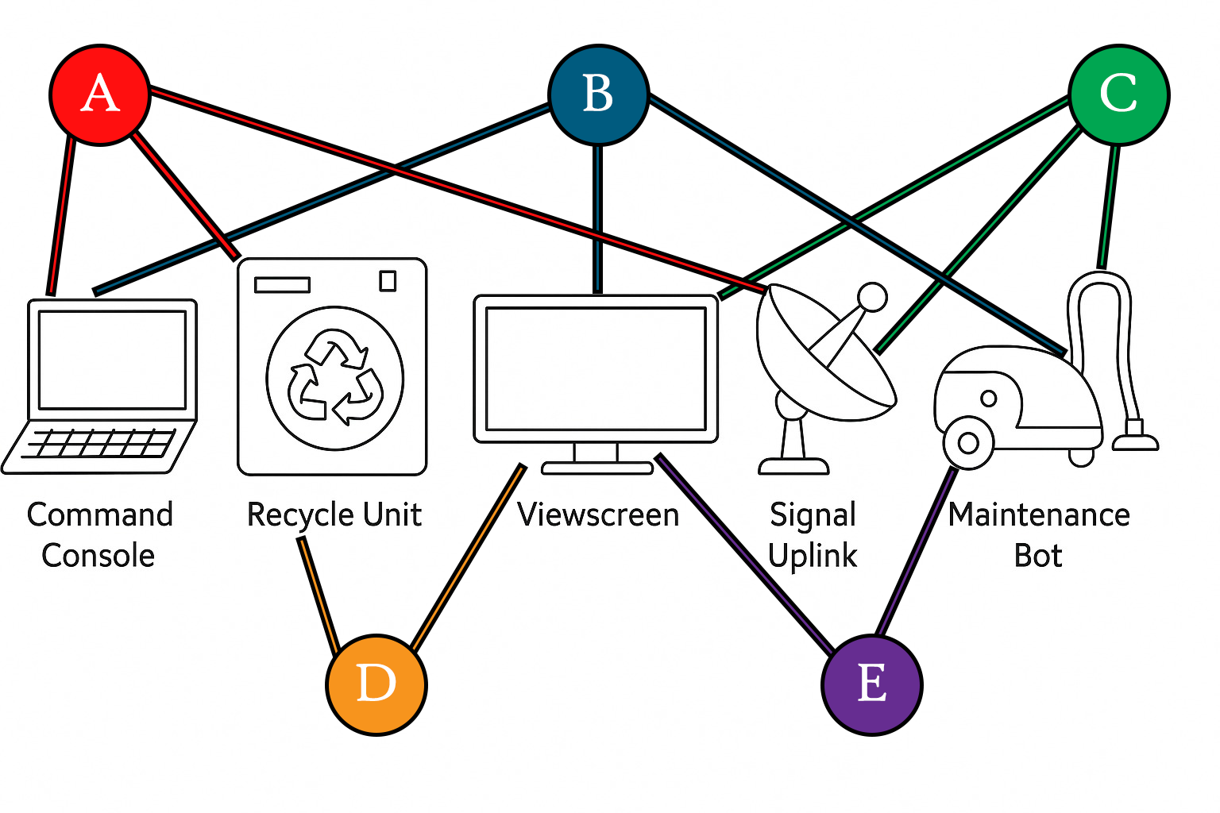
Encounter 1

Encounter 2
FTQ XURQ EGBBADF EKEFQY UE NMP. DQEFMDF UYYQPUMFQXK!
ADD UP SWITCHES USED (A=1, B=2, C=3, D=4, E=5) TO FIND MY CODE.

Fill in the table below with the shifted letters to help you decode the message.
Cypher Key: _____
A | B | C | D | E | F | G | H | J | K | L | M
N | O | P | Q | R | T | U | V | W | X | Y | Z
Message:

What does the captain need you to do now? ________________________

Encounter 3
Follow the reboot instructions carefully to find the rest of the correct reboot order. Captain Arden’s message specifically said to restart a certain system first. What was it?

Reboot Instructions:
- The system from the Captain’s message must restart first.
- Navigation can only restart after Communications.
- Engines need Navigation online first.
- Shields must reboot after Engines.
- Sensors must restart immediately after Life Support.
- Artificial Gravity must restart after Sensors, but before Communications.
- Defence Systems must reboot after Communications, but before Navigation.

Ship Systems and their System IDs:
System | System ID
Engines | 1
Artificial Gravity | 2
Life Support | 3
Communications | 4
Navigation | 5
Shields | 6
Sensors | 7
Defence Systems | 8

Write your reboot order clearly here:
- ___________________ ID:____
- ___________________ ID:____
- ___________________ ID:____
- ___________________ ID:____
- ___________________ ID:____
- ___________________ ID:____
- ___________________ ID:____
- ___________________ ID:____

Encounter 4
Captain Arden left one last clue: “Use the reboot code to initialise the robot’s movement program.”
Use the 8-digit reboot code from the last puzzle to control the navigation robot.
Each number in the code tells the robot to make a move:
- 1 = Move up
- 2 = Move down
- 3 = Move left
- 4 = Move right
- 5 = Move one space in the same direction as last time
- 6 = Spin (do nothing)
- 7 = Move diagonally up-right
- 8 = Move diagonally down-left
Start the robot at the middle of the 5x5 grid below. Follow each instruction in order to find out where the robot ends up!
 | 1 | 2 | 3 | 4 | 5
1
2
3 |  |  | 🤖
4
5

Write down the final position of the robot here: ________________

Encounter 5
